# Week1

1 R and RStudio

Integer

* Examples: 1L, 2L, 42L
* Vectors in R are indexed starting at 1
* Assignment operator use =, instead of <-

2. Data

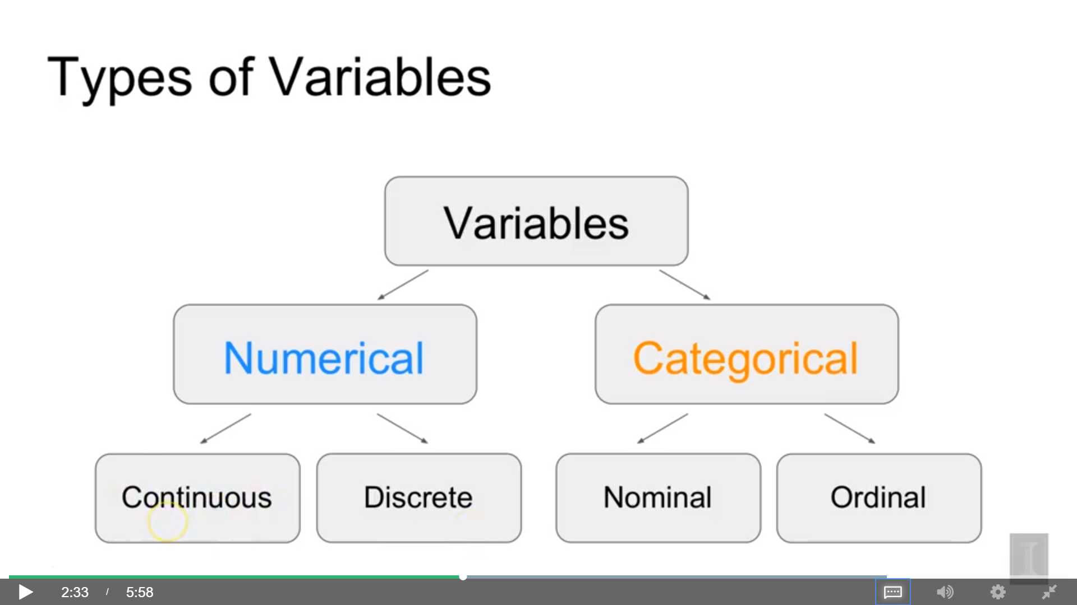

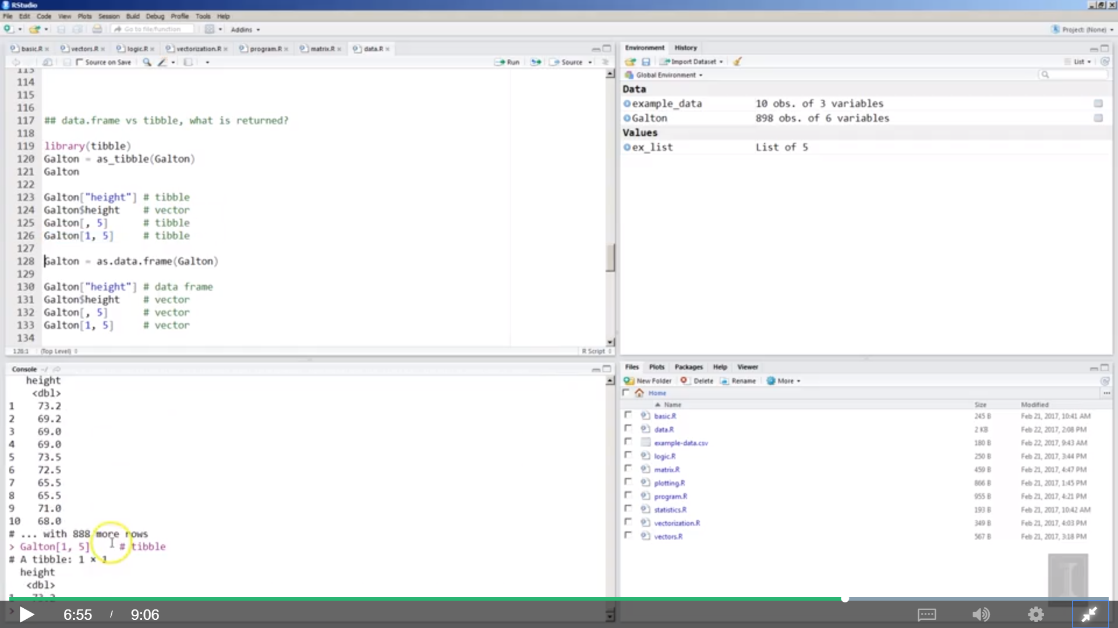

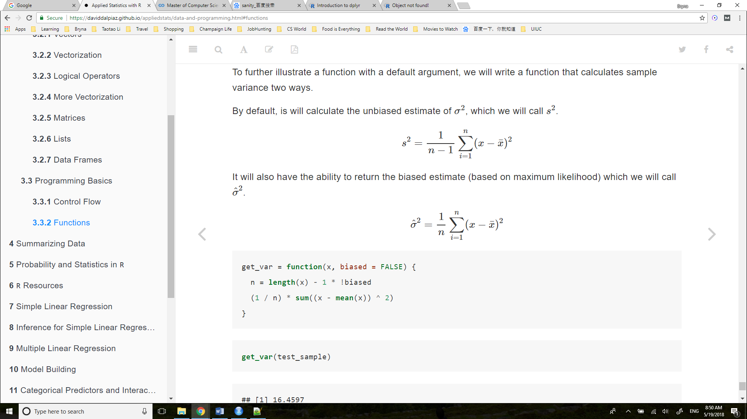

# Week2

Broadly speaking, we would like to model the relationship between X and Y using the form

Y=f(X)+ϵ.Y=f(X)+ϵ.

The function ff describes the functional relationship between the two variables, and the ϵϵ term is used to account for error. This indicates that if we plug in a given value of XX as input, our output is a value of YY, within a certain range of error. You could think of this a number of ways:

* Response = Prediction + Error
* Response = Signal + Noise
* Response = Model + Unexplained
* Response = Deterministic + Random
* Response = Explainable + Unexplainable

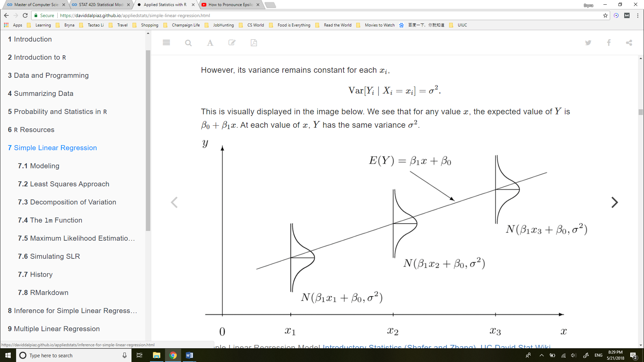

**LINE**.

* **L**inear. The relationship between Y and x is linear, of the form β0+β1x.
* **I**ndependent. The errors ϵ are independent.
* **N**ormal. The errors, ϵ are normally distributed. That is the “error” around the line follows a normal distribution.
* **E**qual Variance. At each value of x, the variance of Y is the same, σ2.

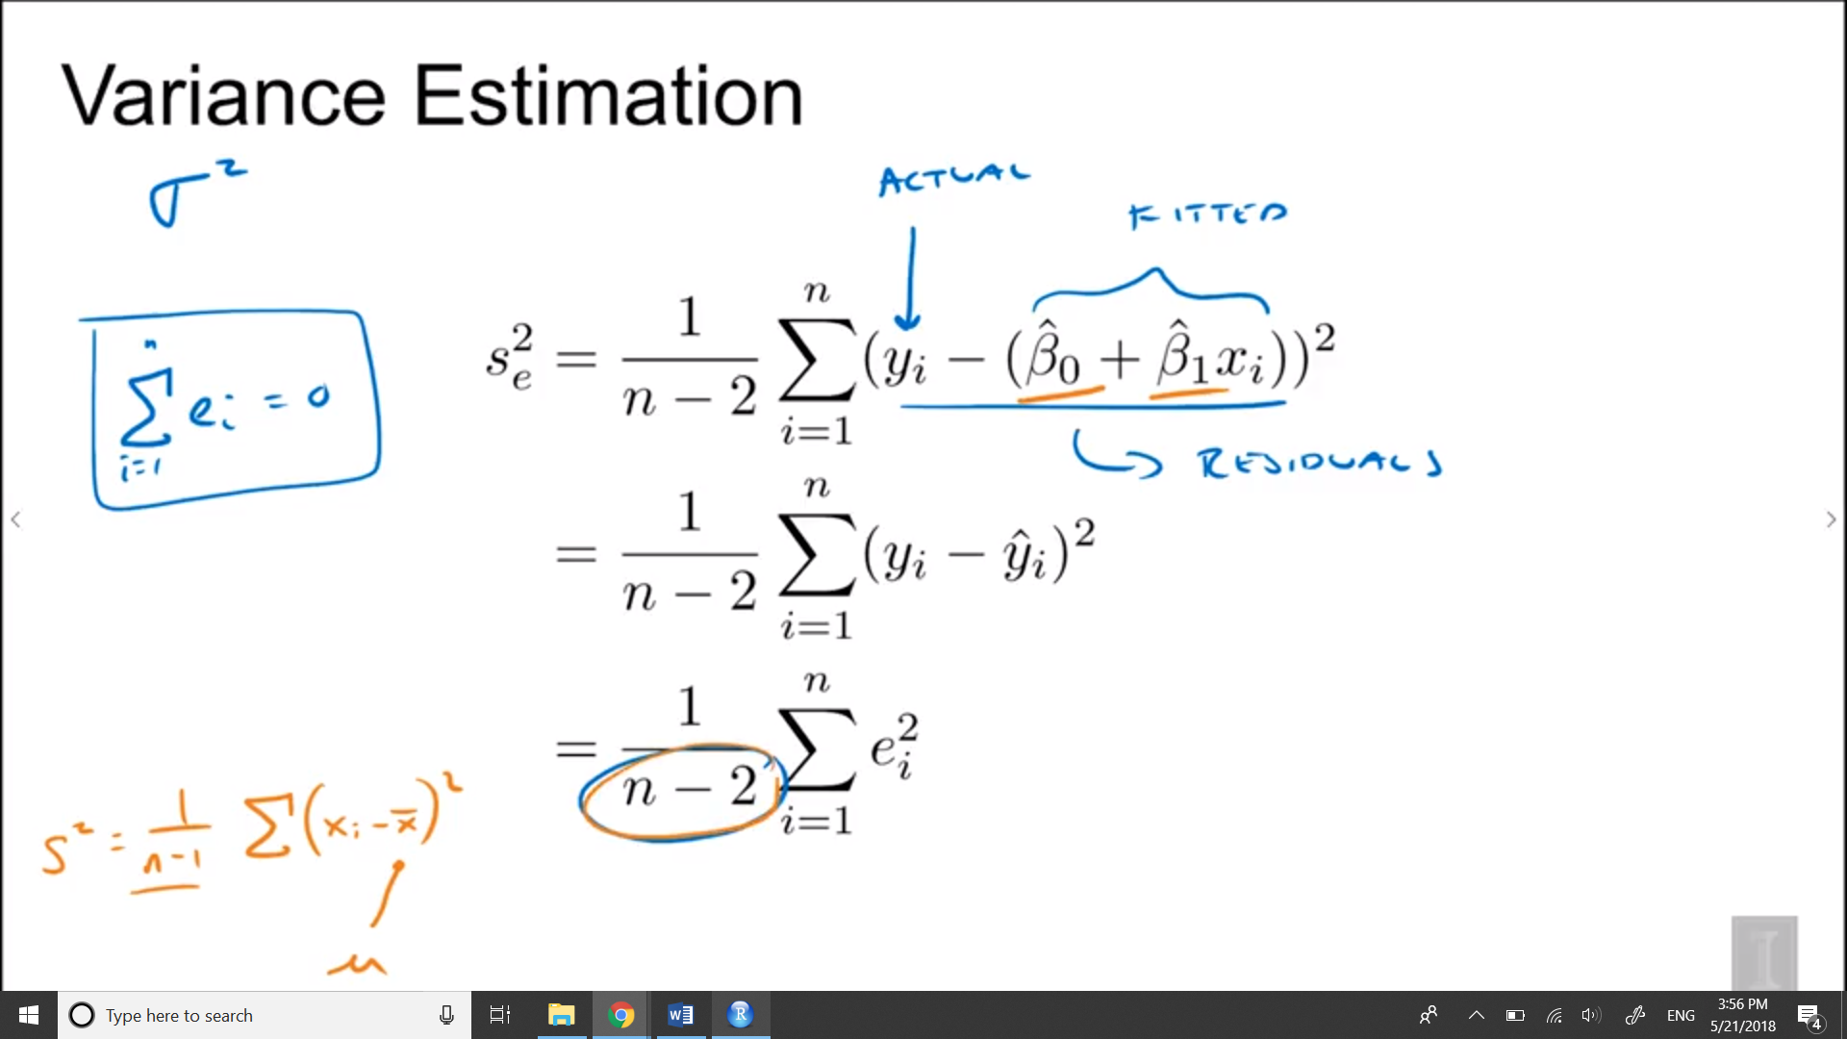

And so here we an n- 1, and that's because this x bar here is an estimate of mu. So we estimate one parameter, so we say we lose a degree of freedom. So we had to divide by n- 1, so that's similar to why we had to divide by n- 2 here. Because we had to estimate two parameters before calculating the estimate of the variance

## 7.2 Least Squares Approach

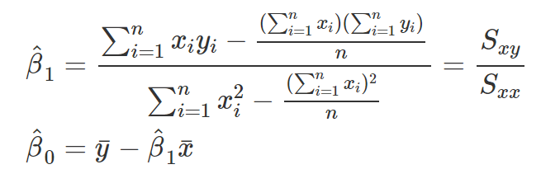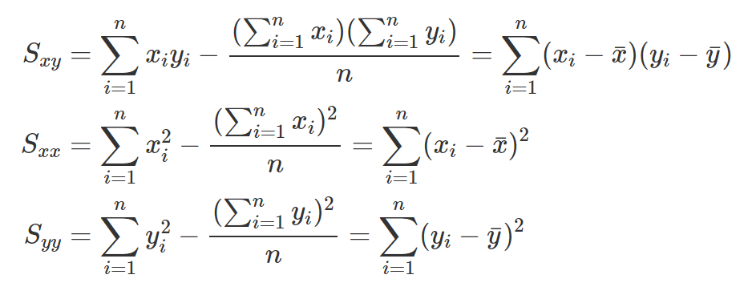

#### Sum of Squares Total

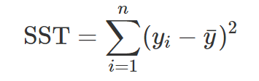

#### Sum of Squares Regression

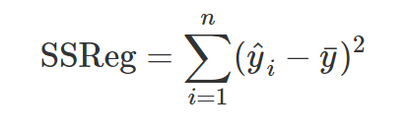

#### Sum of Squares Error

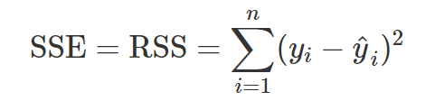

“Sum of Squares Error,” SSE, represents the **unexplained variation** of the observed y values. You will often see SSE written as RSS, or “Residual Sum of Squares.

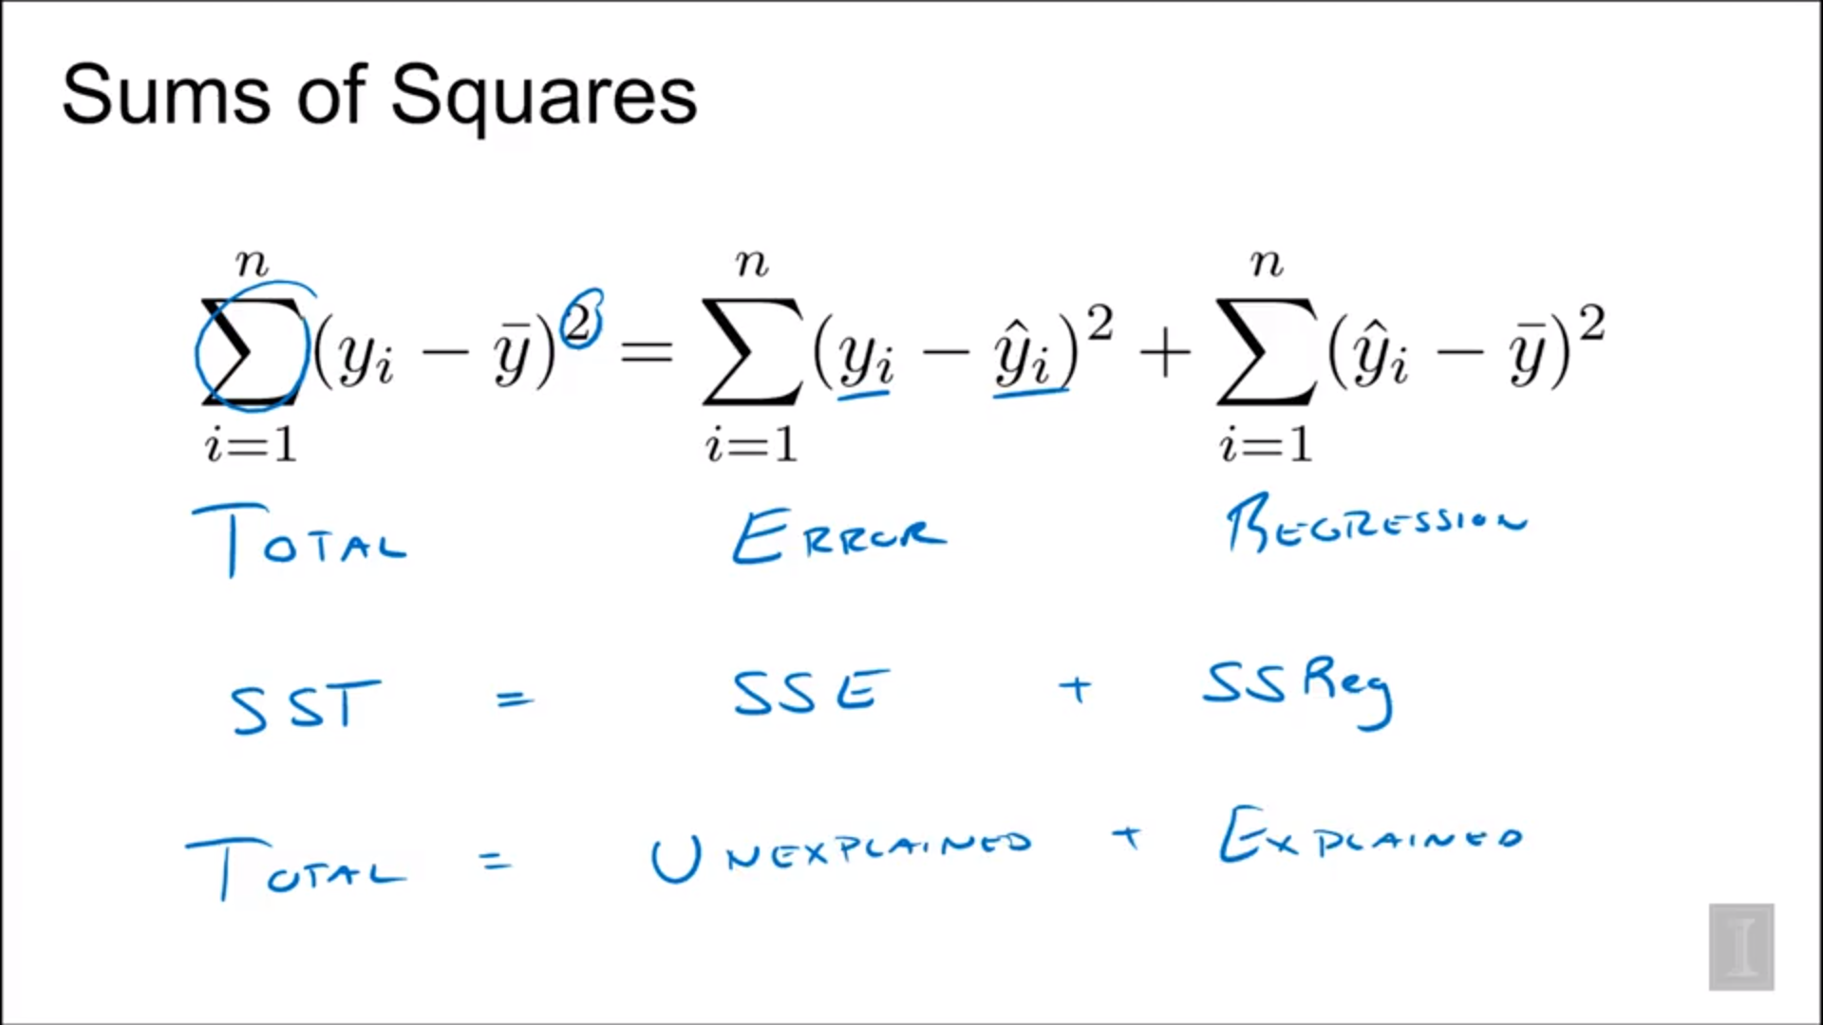

### Coefficient of Determination

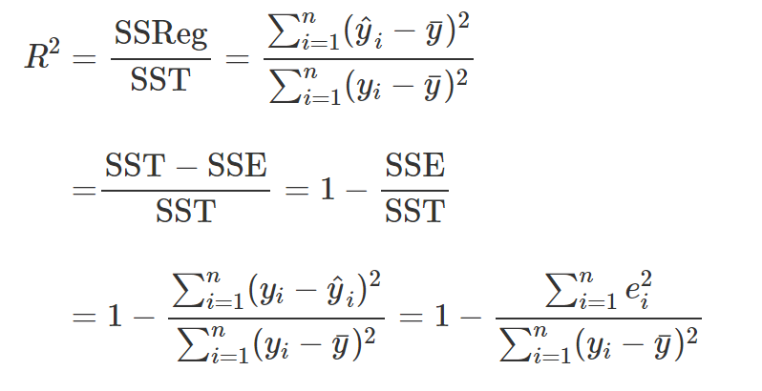 SSE = SEline, SST = SEy

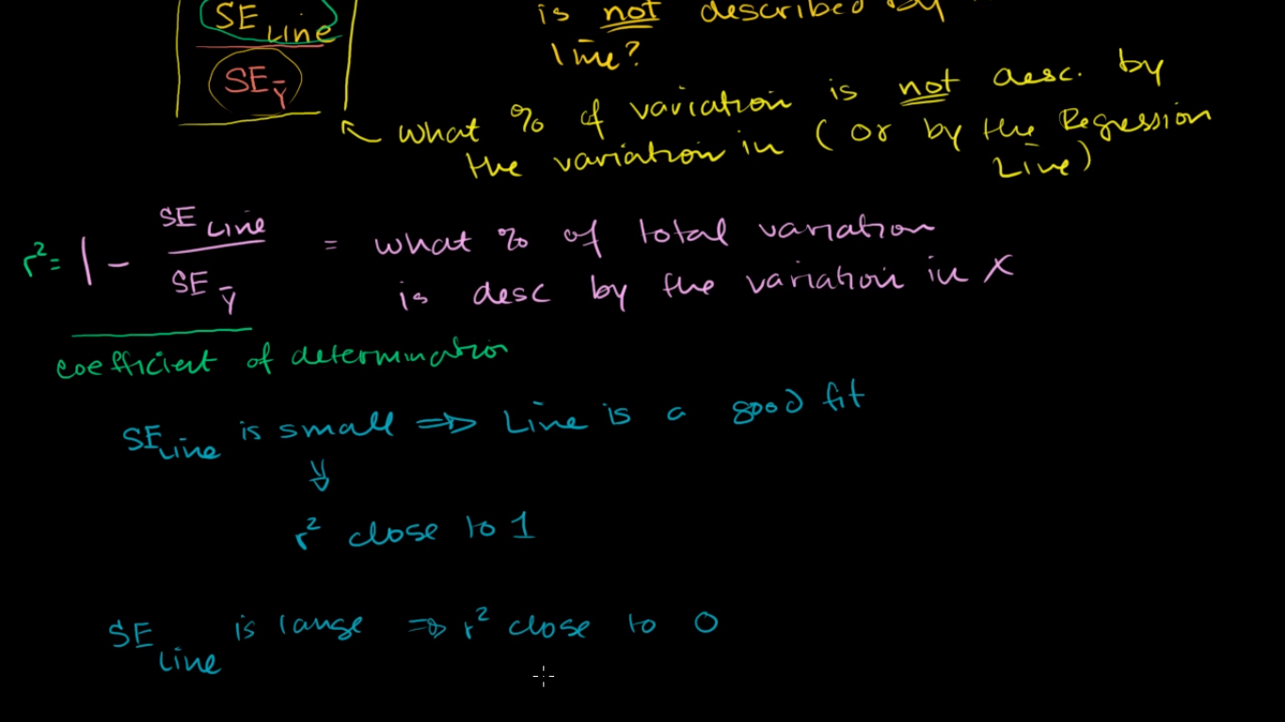

the regression makes up a much larger portion of the total line than the error does

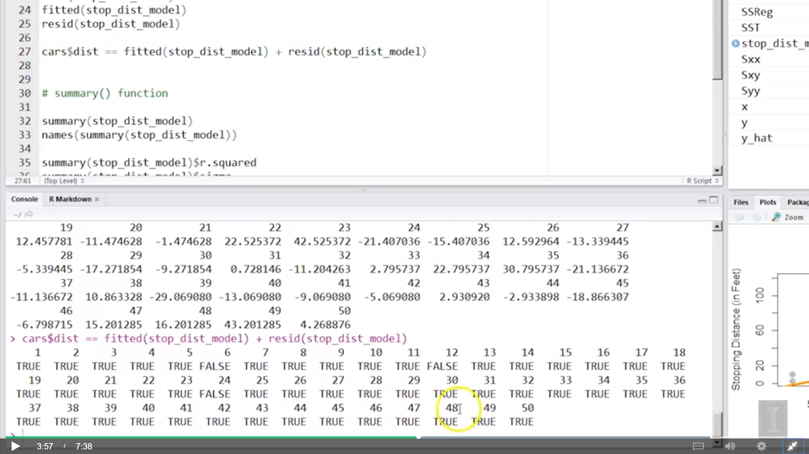

## Probability vs Likelihood

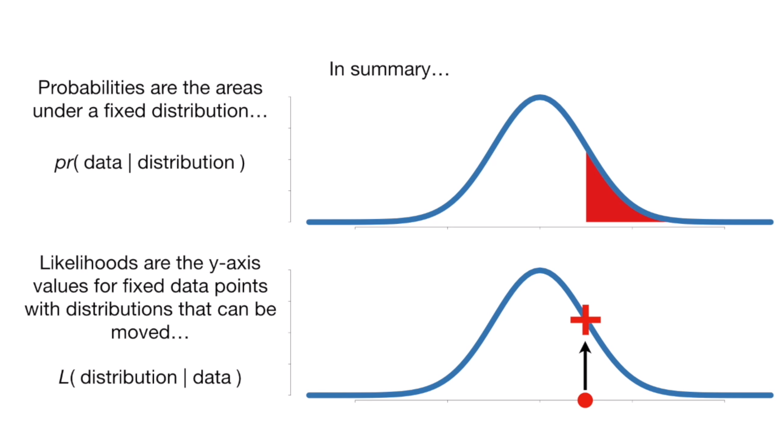

## 7.5 MLE

# Week3

## 8.1 Gauss–Markov Theorem

The **Gauss–Markov theorem** tells us that when estimating the parameters of the simple linear regression model β0 and β1, the β^0 and β^1 which we derived are the **best linear unbiased estimates**, or BLUE for short.

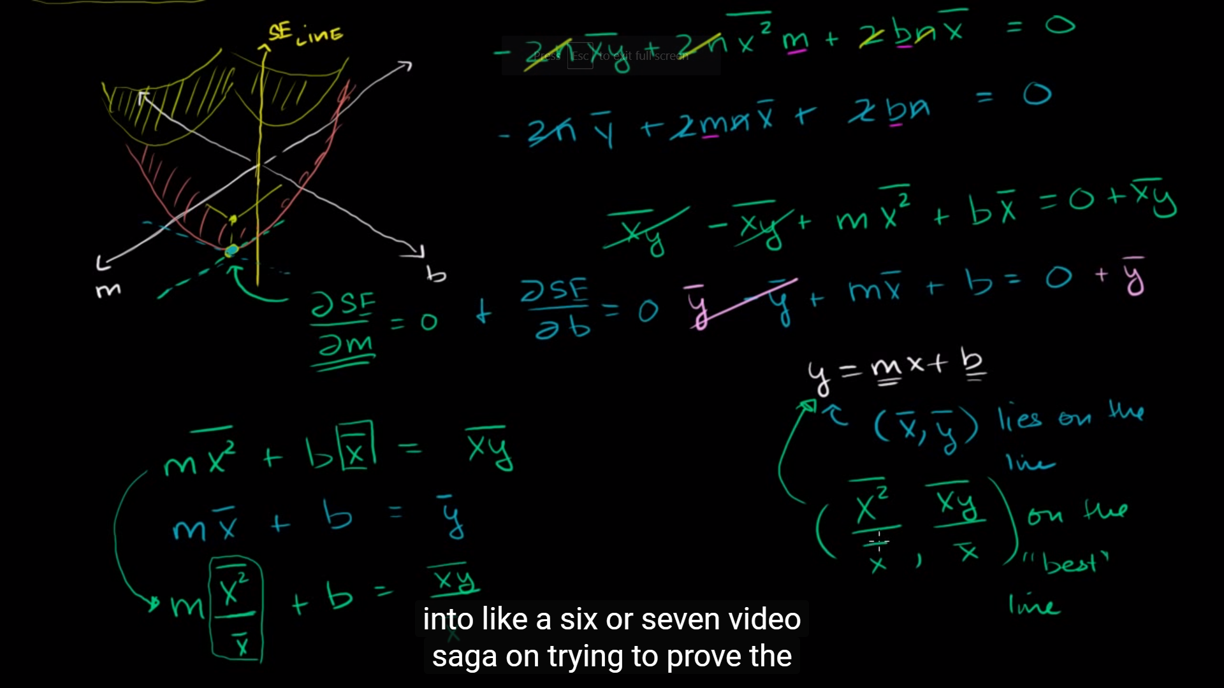

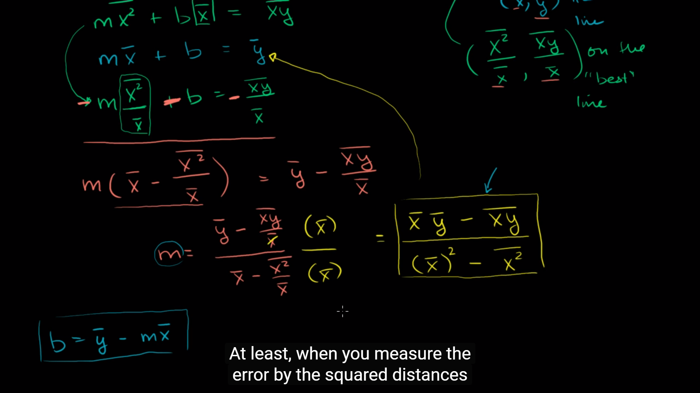

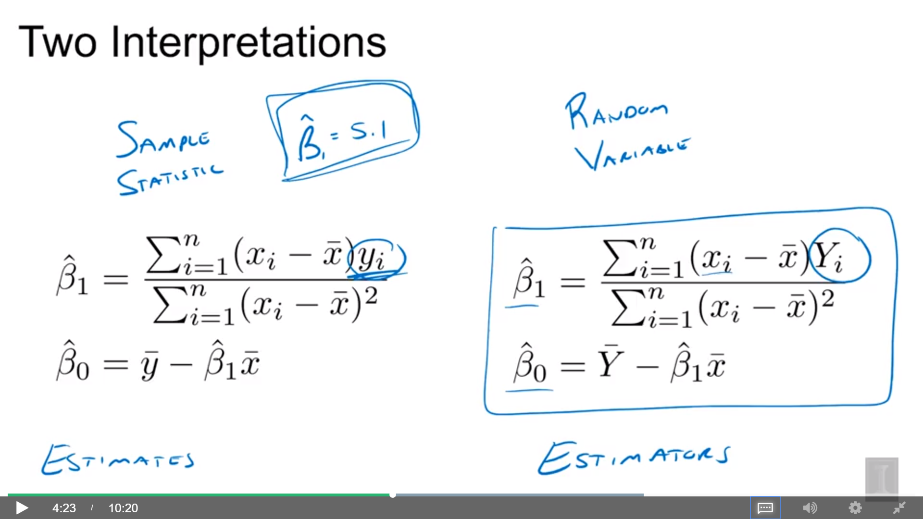

Sample vs Random Variables

Estimates vs Estimators

An estimate is a particular value of an estimator for a given dataset. So when you apply the estimator to a dataset, you get an estimate.

z-score vs t-score

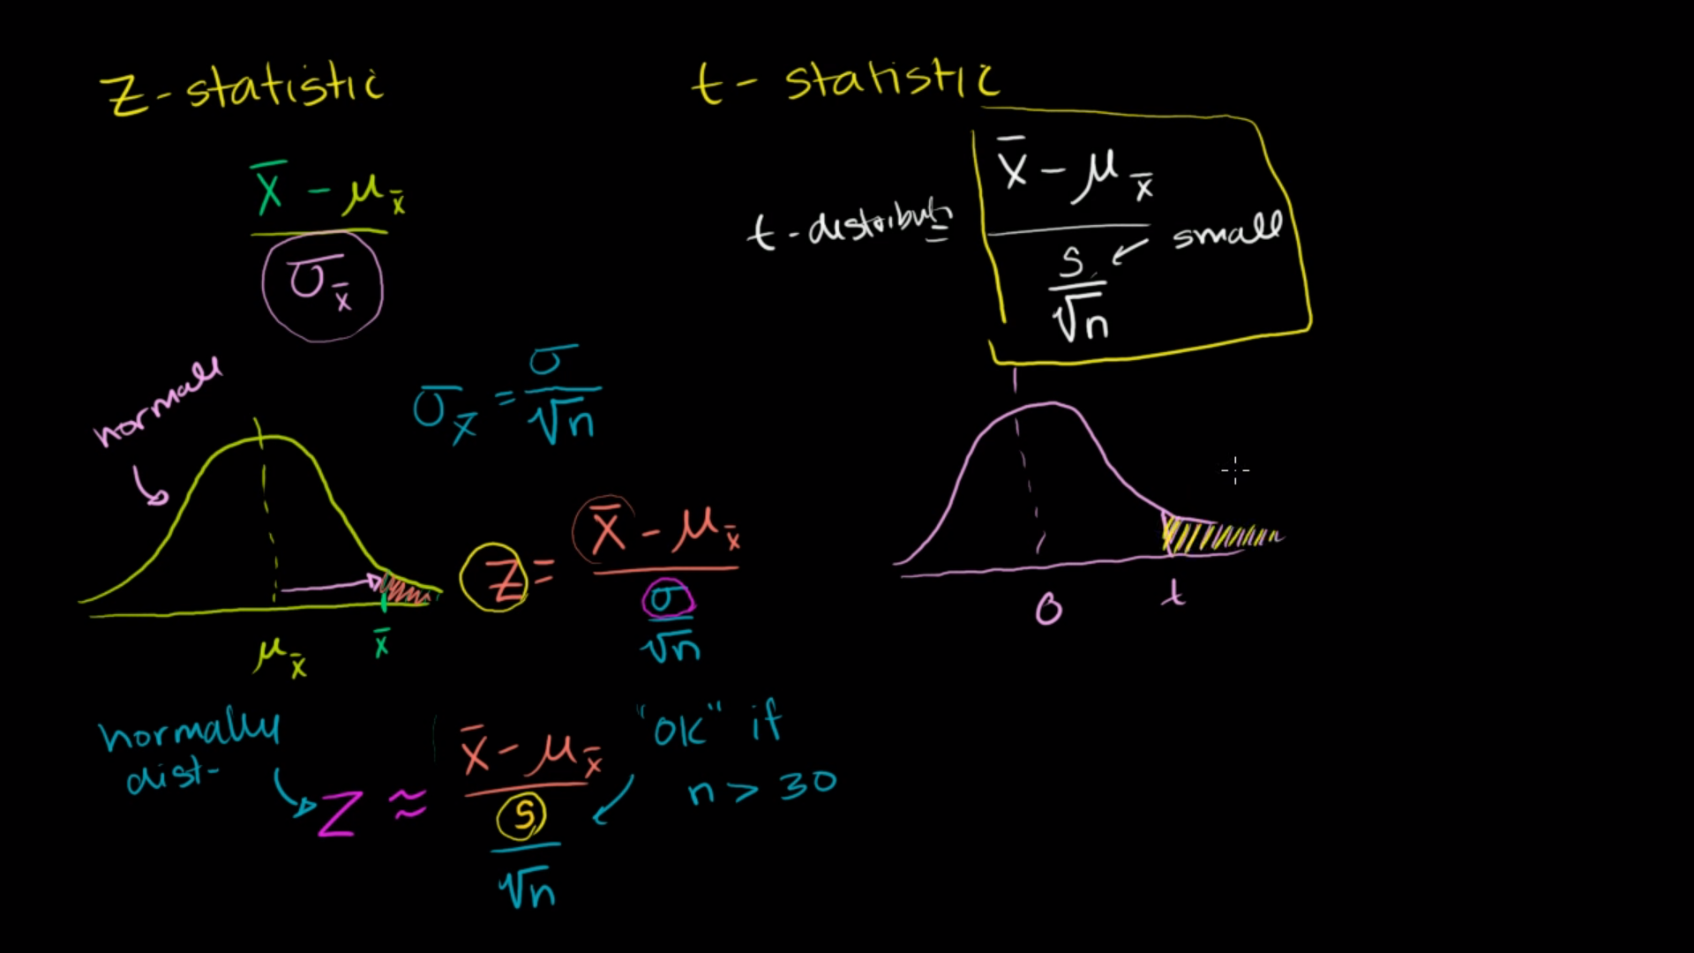

## 8.3 Standard Errors

Standard normal, mean = 0, variance = 1

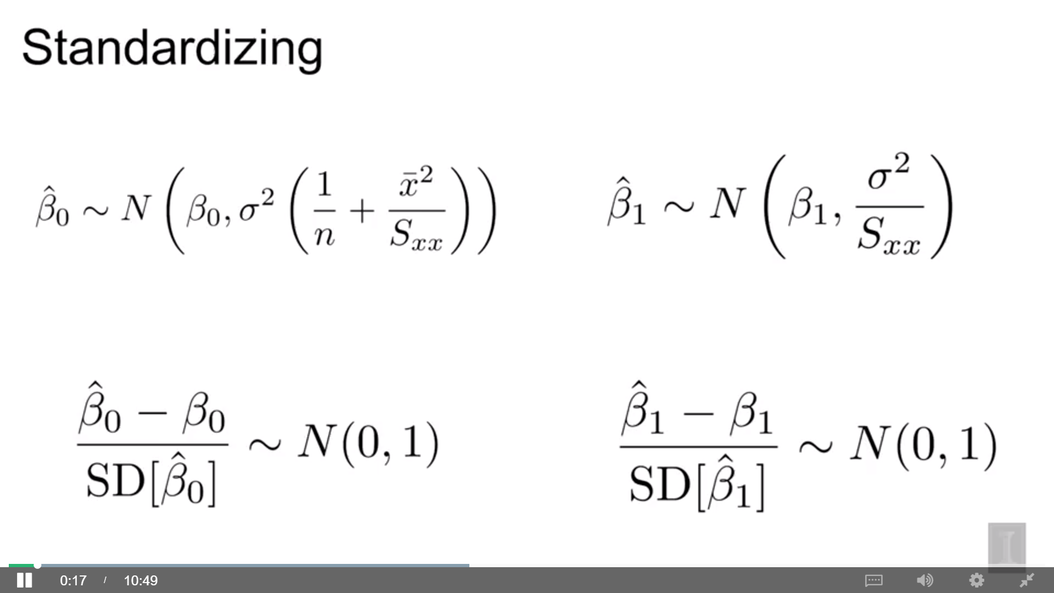

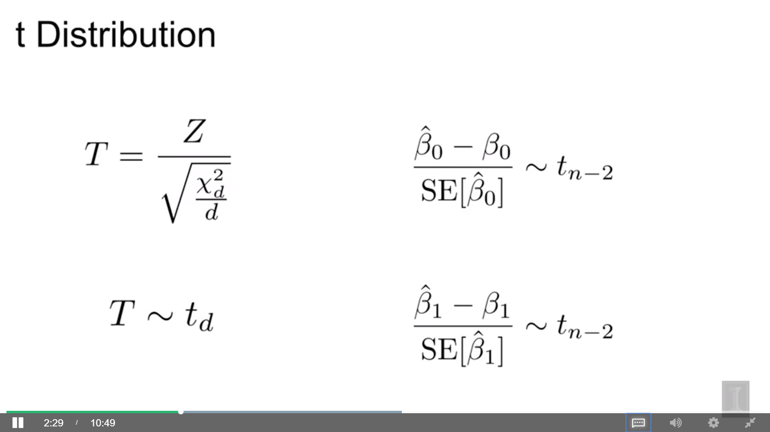

after doing this new standardization procedure where we divide by the standard error instead of standard deviation.

If we have a random variable t and it’s a ratio of on top, Z (a standard normal random variable) and on the bottom, the square root of a chi-squared distribution with d degrees of freedom divided by d, it follows a t distribution with d degrees of freedom

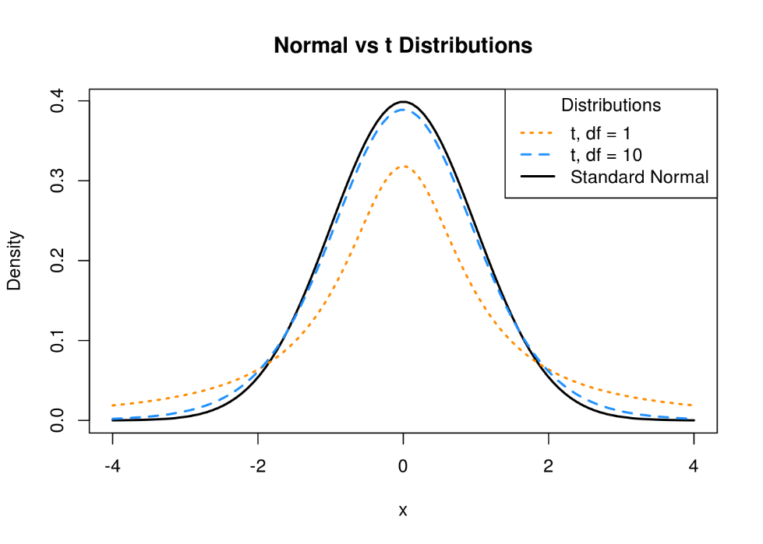

A t distribution with any degrees of freedom: mean = 0, symmetric

A t distribution is similar to a standard normal, but with heavier tails, a normal distribution has more of its density closer to the mean while t distributions are more spread out

How spread out is dependent on their degrees of freedom: as degrees of freedom increases, the tail has less of density and more of it is closer to zero and become more like a standard normal distribution

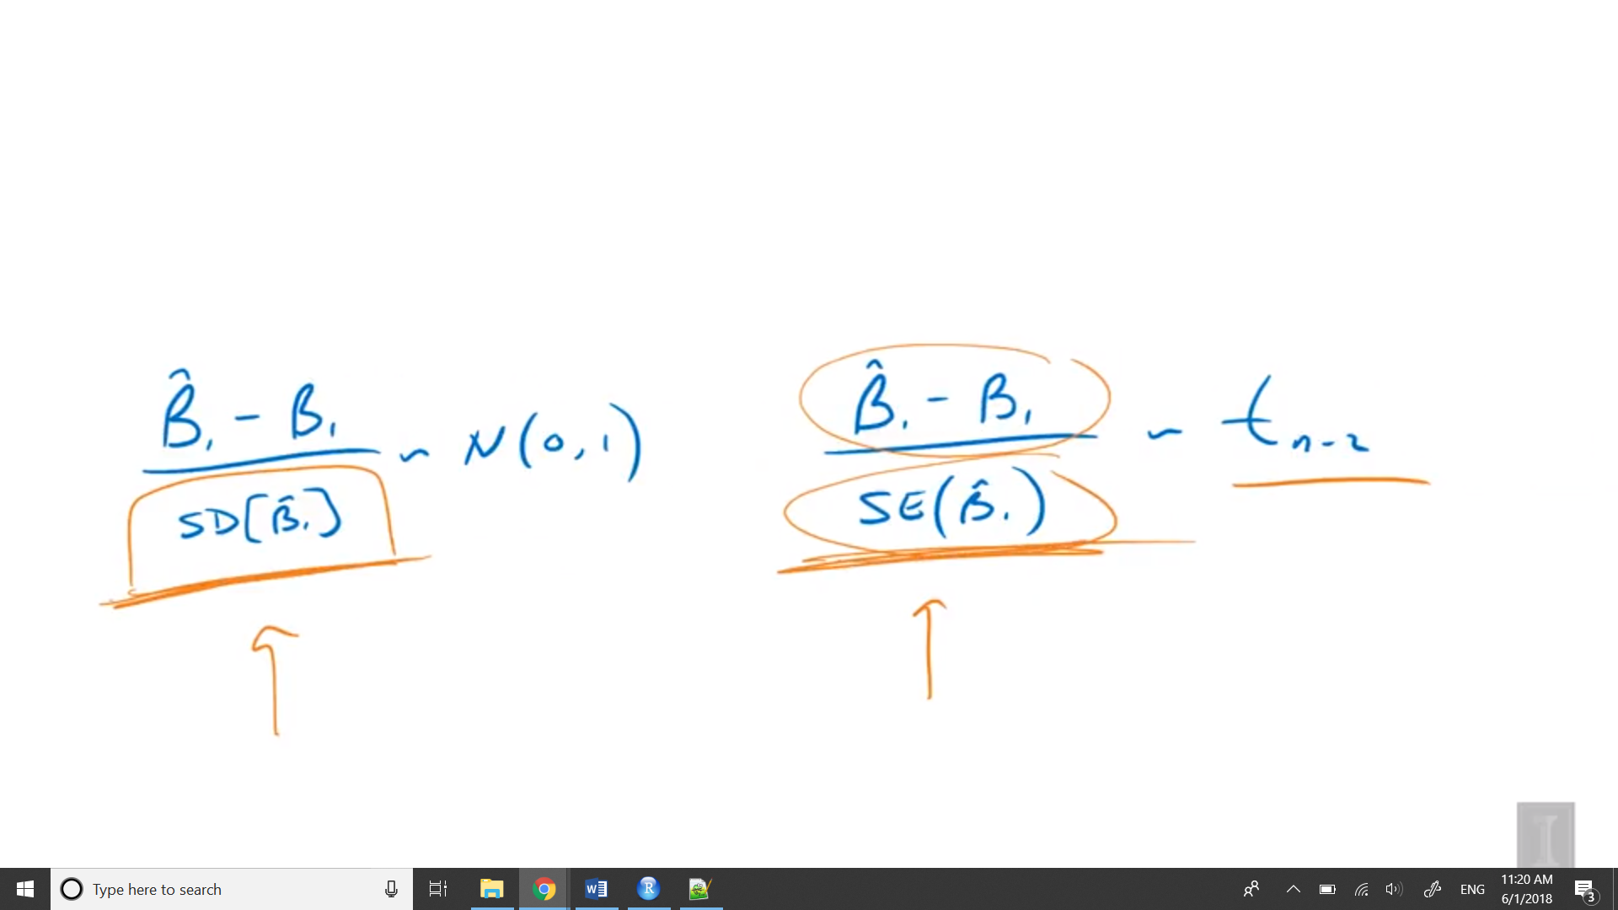

Since we’re using standard error, it’s becoming more variable

As the sample size grows, the degrees of freedom grow and t distribution become closer to the standard distribution

## 8.4 Confidence Intervals for Slope and Intercept

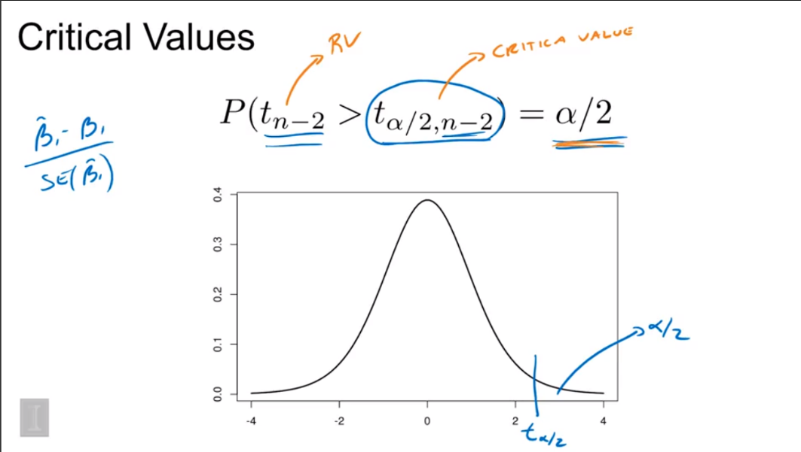

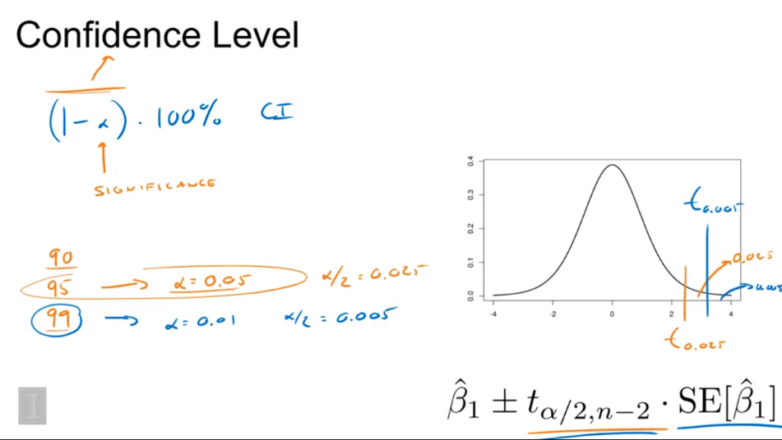

Higher confidence level needs larger interval (blue)

The width of the interval is based on two things:

1. Standard error, we don’t control
2. Critical value, have some control via the confidence level

We are 99% confident that the true change in mean stopping distance for an increase in speed of one mile per hour is between 2.81 and 5.05

## Mean response

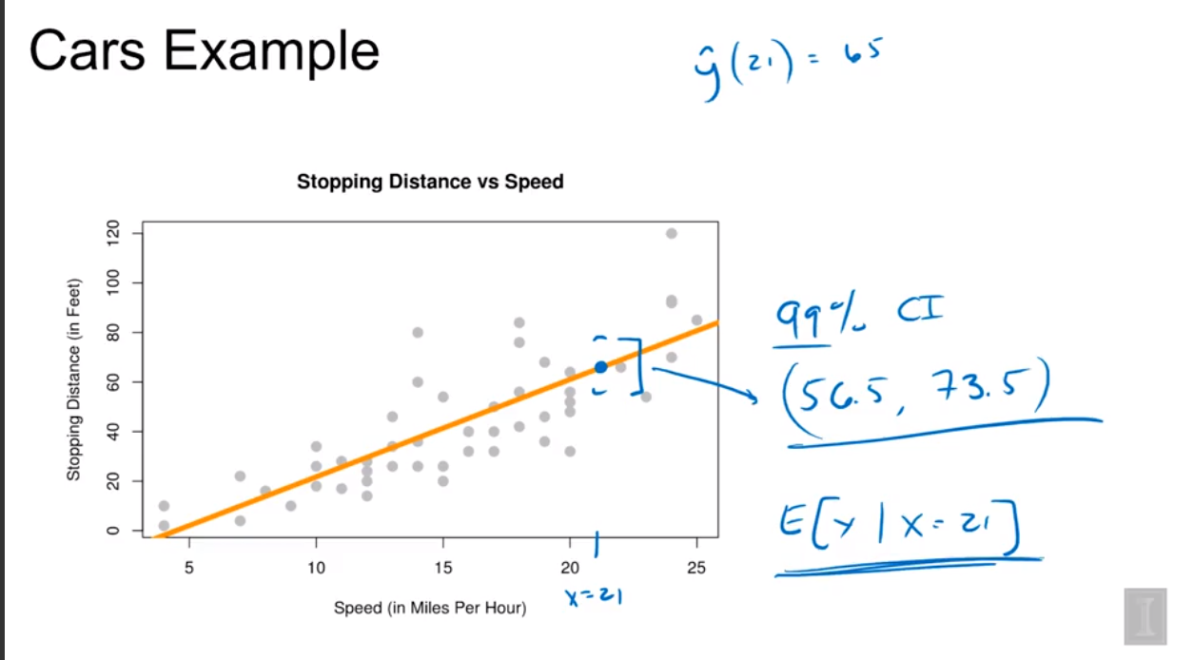

The further away from the sample mean of x, the larger the standard error is going to be.

The mean of y that is the stopping distance when x is 21.

This interval is for the mean of y, capturing is where we think this regression line would be for an x of 21, not all the potential observations for x of 21.

## Prediction Intervals

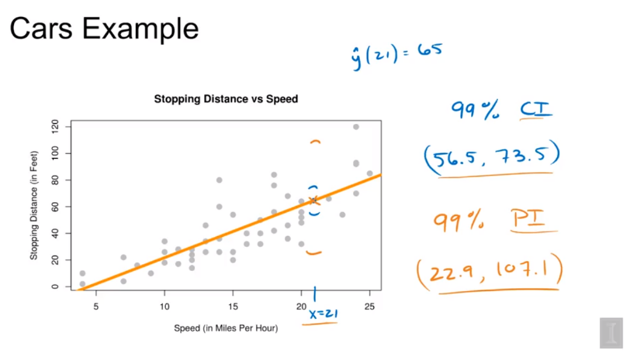

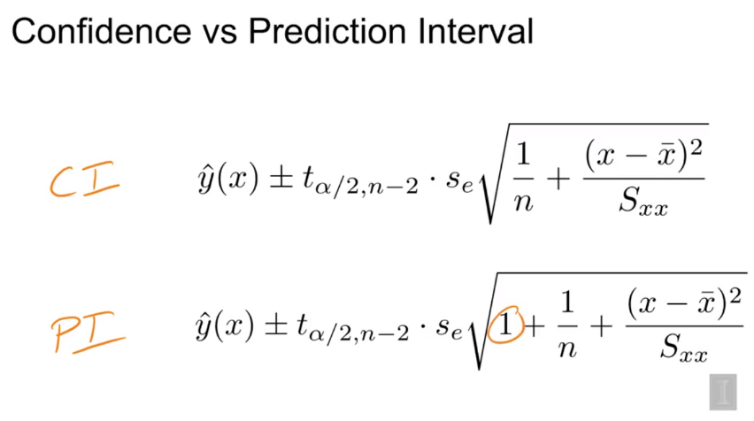

Also, both intervals are at its narrowest when we’re predicting at x bar and the further we get away, the wider the interval gets, since there’s less data near the points that we’re predicting at.

## 8.5 Hypothesis Tests

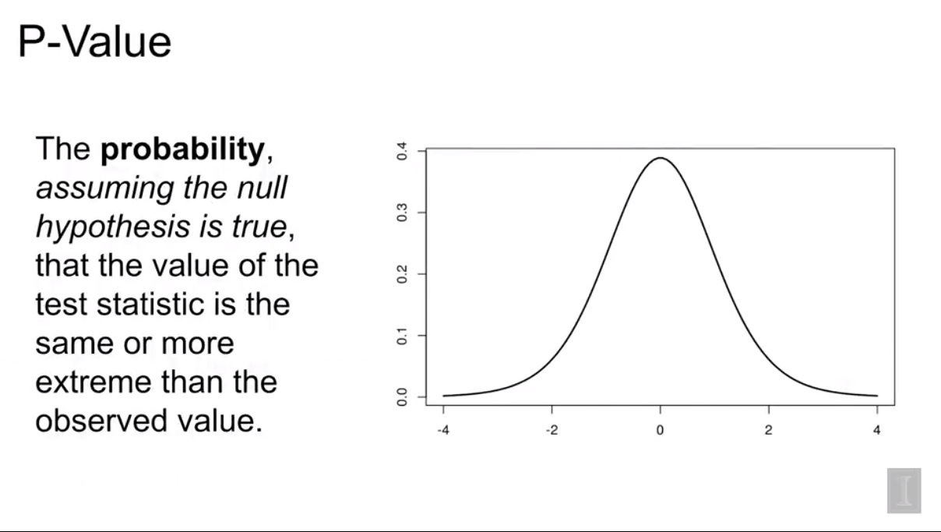

1. Test for whether or not we need to use a line to model the data ( H0: there is no significant linear relationship between x and y)

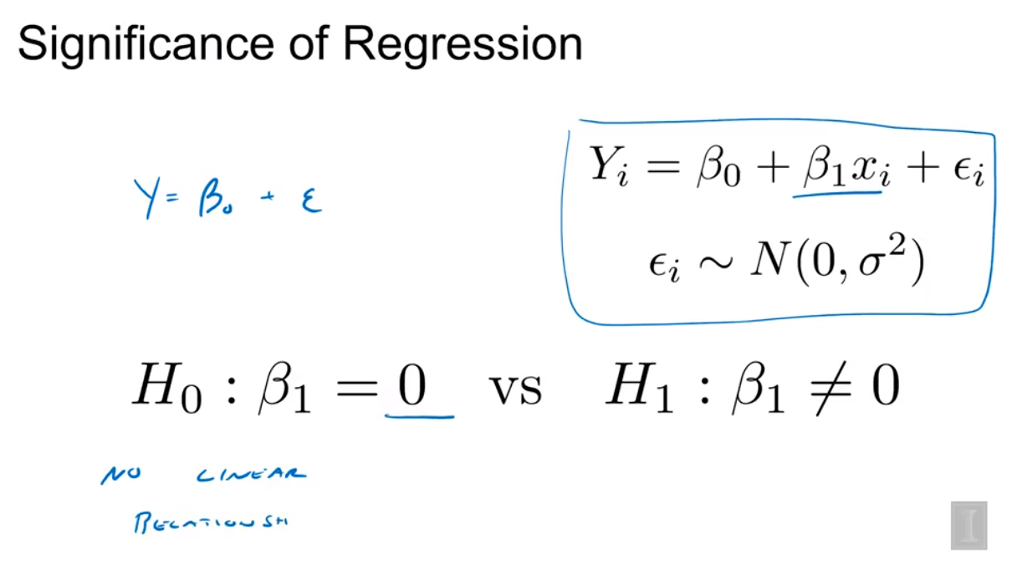

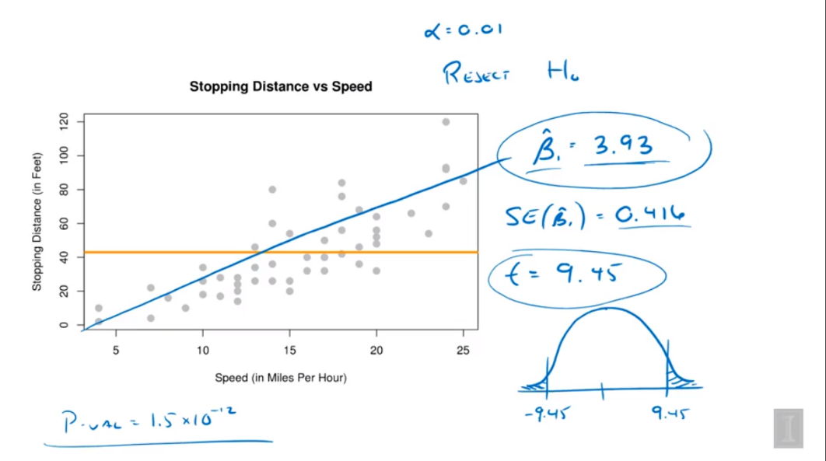

p-value < 0.01, reject H0 => there is a linear relationship

1. Confidence Interval

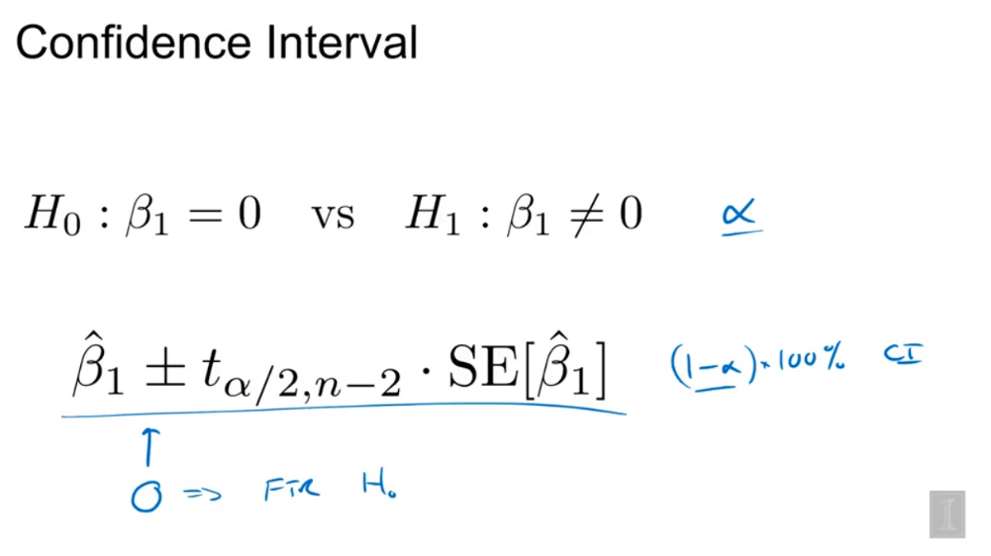

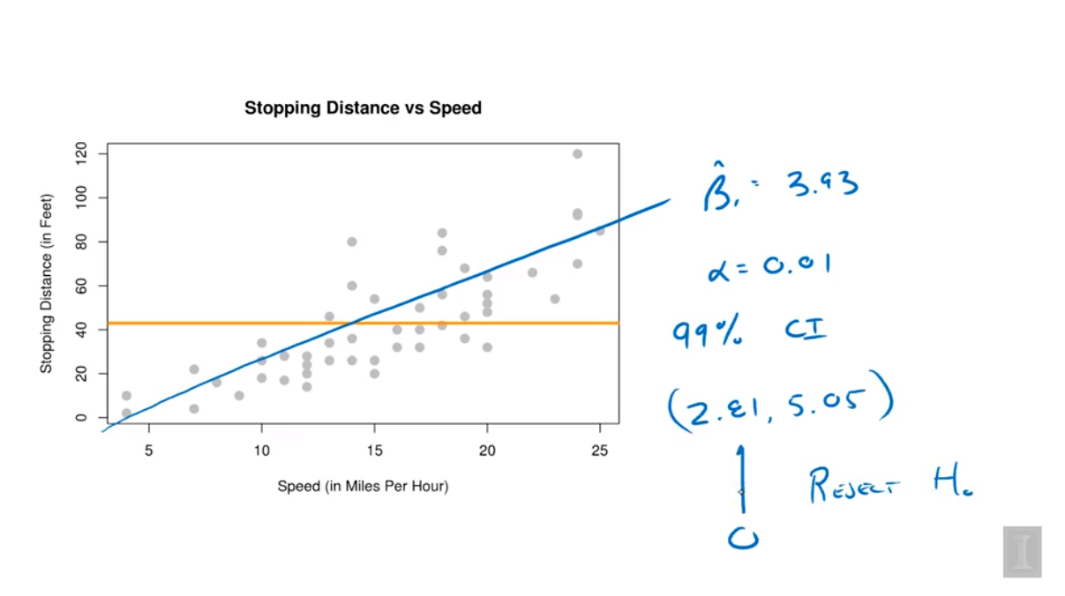

0 is outside of the interval => reject H0

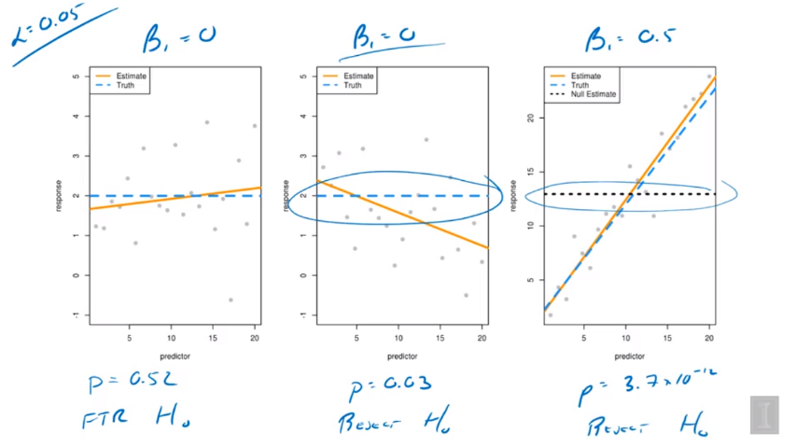

1. P = 0.52 > 0.05, fail to reject H0 => no linear, correct
2. P = 0.03 < 0.05, reject => linear, wrong
3. P = 3.7 * 10-12 < 0.05, reject => linear, correct

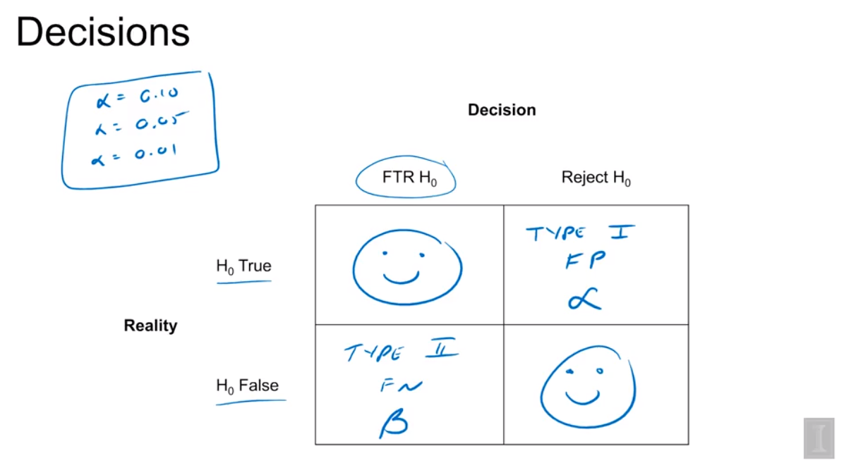

Type 1 Error: just like Pic2, reject a True H0, there is no relationship, control alpha

Type 2 Error: fail to reject a False H0, there is relationship, beta